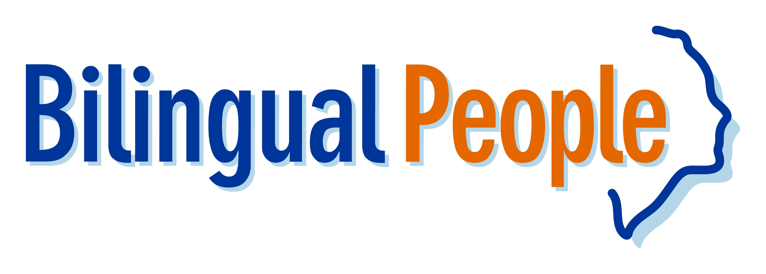

International Language Recruitment Day, 28th Sept, Krakow
The Bilingual People Language Recruitment Fair, sponsored by www.toplanguagejobs.pl , is the largest and most exciting exhibition of its kind dedicated to bilingual and multilingual recruitment. Due to demand from both language professionals and employers, Bilingual People returns to Krakow for the second year in a row at the Sheraton Hotel Krakow on September 28th. This event allows you to meet and discuss employment opportunities with some of the largest recruiters in the region and across Europe Face to Face.

The event offers bilingual and multilingual professionals access to hundreds of available positions from leading international companies and recruitment agencies based in Poland and across Europe, in employment sectors such as Customer Service, Accountancy & Finance, IT, Sales, Marketing and Translating/Interpreting, plus many more.

Whether it’s Krakow, throughout Poland or Internationally (Germany, UK, Czech Republic, Spain…) we have companies at the fair who are looking forward to meeting you and looking at making your dream career move a reality.

Confirmed exhibitors include:

BASF – Germany
Top Language Jobs – Europe Wide
Savvis – Poland
Infosys – Czech Republic
Northgate Arinso – Spain
Proxime – UK
Concentrix – UK
Dell – Slovakia
Delegate International Recruitment – UK
Capgemini – Poland
Barona – Poland
Amway Business Centre Europe – Poland
Randstad - Poland

Why you should not miss the Bilingual People Fair :
- Multinational Companies and Recruitment Agencies that are recruiting people with language skills for positions in Krakow, throughout Poland and across Europe including Ireland, UK and Germany.
- Industries ranging from Sales, Customer Service, IT, Tech Support, Accountancy/ Finance and many more will be present at the fair
- You will be able to talk to leading employers and agencies face-to-face and discuss a wide range of employment opportunities.
- Companies will be conducting interviews hoping to hire staff shortly after the event from the people they meet
- A full seminar programme will be taking place through the day by Industry Experts
- Recruitment Professionals will be on hand to give you advice on your CV and Career Coaching.

FREE online tickets will be allocated on a strict first come first serve basis.

For more information about the fair and to register for your FREE ticket visit:
http://www.bilingualpeople.pl/get_ticket?ad=Dulnik13

Partnership: Miasto Kraków

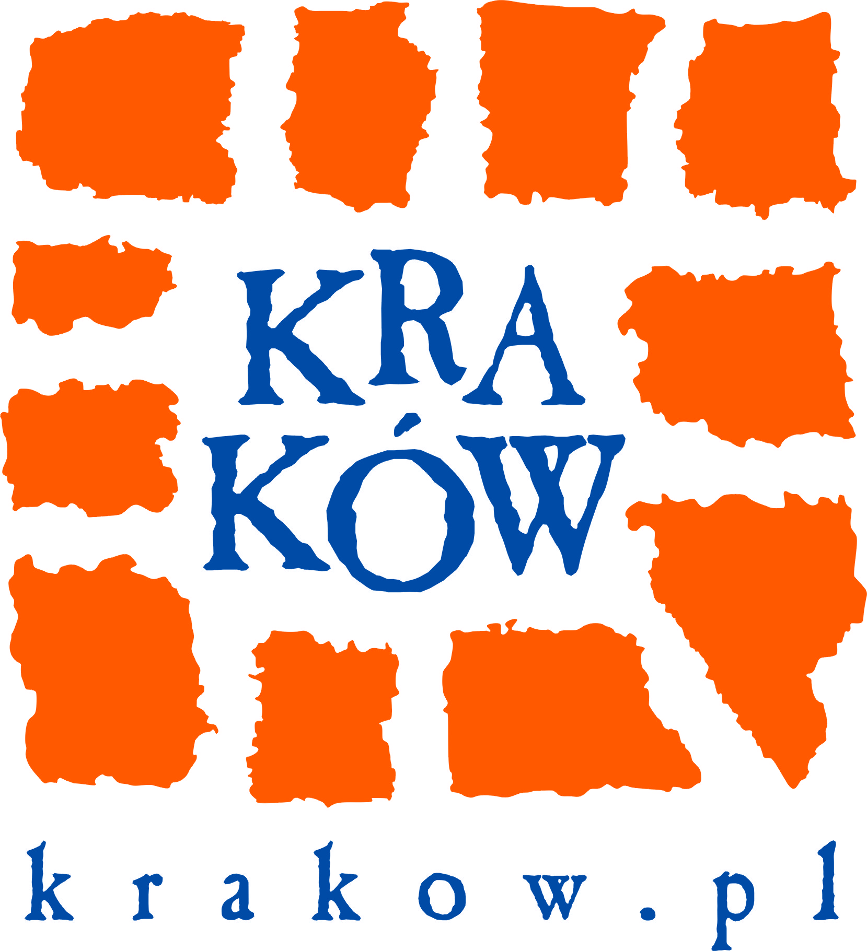

Media Partners:
www.MagicznyKrakow.pl
www.GazetaPraca.pl
www.pracuj.pl
www.KluczDoKariery.pl
www.PracaIzycie.pl
www.aegee.krakow.pl
Future Centre Training Corporation http://www.futurecentre.eu/
Expat Blog http://www.expat-blog.com

We look forward to seeing you there!

Bilingual People Team

